AI Leadership & Project Management

A Masterclass in Leading Successful AI Implementations

Dr. Michael Borck

# Welcome



* “Today isn’t about theory - it’s about practice”
* “You’ll work hard, think critically, make difficult decisions”

# Today’s Journey

**Timeline for the Day:**

* 9:00-10:30am → **Foundations & Frameworks**
* 10:30-11:00am → Morning Tea
* 11:00-12:30pm → **Stakeholder Management & Project Scoping**
* 12:30-1:15pm → Lunch & Networking
* 1:15-2:30pm → **Crisis Management in Action**
* 2:30-3:00pm → Afternoon Tea
* 3:00-4:00pm → **Strategic Decisions: Scale or Kill**
* 4:00-4:30pm → **Personal Action Planning & Framework Synthesis**
* “This is a full, intense day but incredibly rewarding”
* “You’ll leave with practical skills, not just notes”
* “Every exercise builds on previous learning”

# Learning Outcomes

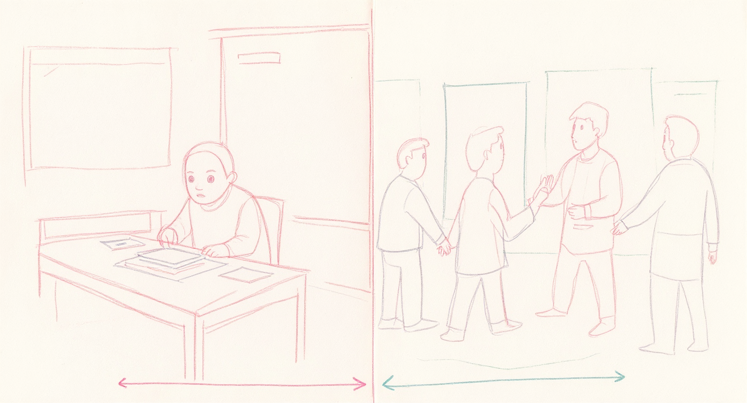

**You will:** - Design • Manage • Navigate • Decide • Apply

* “These aren’t just academic goals”
* “By end of today: Design AI projects with appropriate scope and success metrics”
* “Manage diverse stakeholders effectively in AI initiatives”
* “Navigate ethical dilemmas and value-based decision making”
* “Make informed scale/pivot/kill decisions for AI pilots”
* “Apply crisis management frameworks to real AI project challenges”
* “You’ll actually PRACTICE each of these today”
* “You’ll leave with tools you can use Monday morning”

**Lecture vs. Practice**

Lecture → Decision-making Notes → Action Passive → Active Theory → Muscle Memory

* “Today you’ll experience what AI project leadership FEELS like”
* “The crises you’ll face are based on real projects”
* “Some of you will feel uncomfortable - that’s where learning happens”

# The Reality of AI Projects

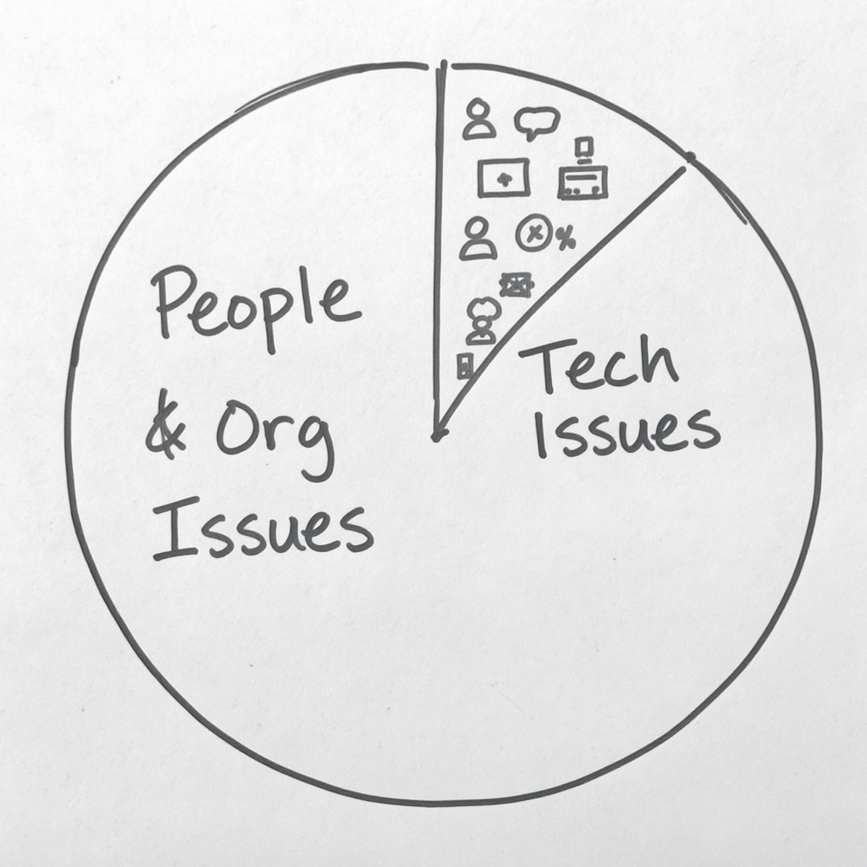

The Brutal Truth About AI Projects. **80% of AI projects fail to deliver value**

*Source: Gartner, 2023*

* “Let that sink in - 4 out of 5 AI projects fail”
* “Technical Issues: 20% - Algorithm doesn’t work, Data quality problems, Infrastructure failures”
* “People & Organisational Issues: 80% - Stakeholder resistance, Unclear objectives, Poor change management, Ethical oversights, Wrong metrics, Scope creep”
* “Not because technology doesn’t work…”
* “AI project leadership is NOT primarily about technology”
* “It’s about people, politics, and change”
* “That’s what we’re focusing on today”

# Real AI Project Failures

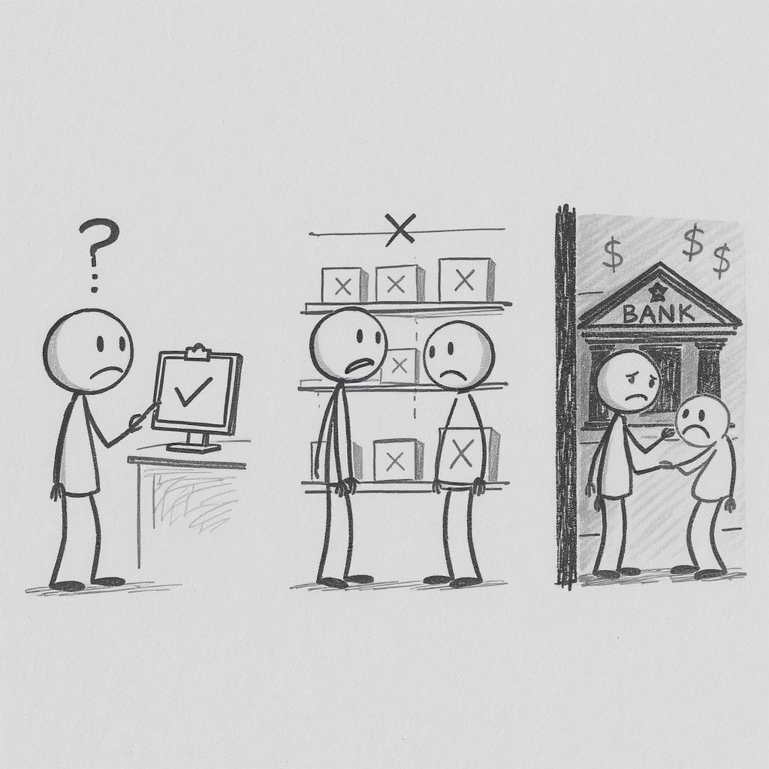

🏥 Healthcare: Perfect algorithm, clinicians didn’t trust it

🏪 Retail: Worked great, destroyed jobs and PR

💰 Banking: Solved the problem, discriminated against people

* “These are real projects (anonymised)”
* “Healthcare: $5M investment, 2-year development, 95% accuracy in lab testing. Clinicians refused to use it. Forgot about user adoption.”
* “Retail: Reduced stockouts by 40% (success!). Automated away jobs, union backlash, PR disaster. Didn’t manage people impact.”
* “Banking: Improved processing speed by 70%. Discriminated against protected groups. Ethical oversight missing.”
* “All had solid technology”
* “All failed because of people and process issues”
* “Today you’ll practice navigating exactly these challenges”

# Traditional vs. AI Projects

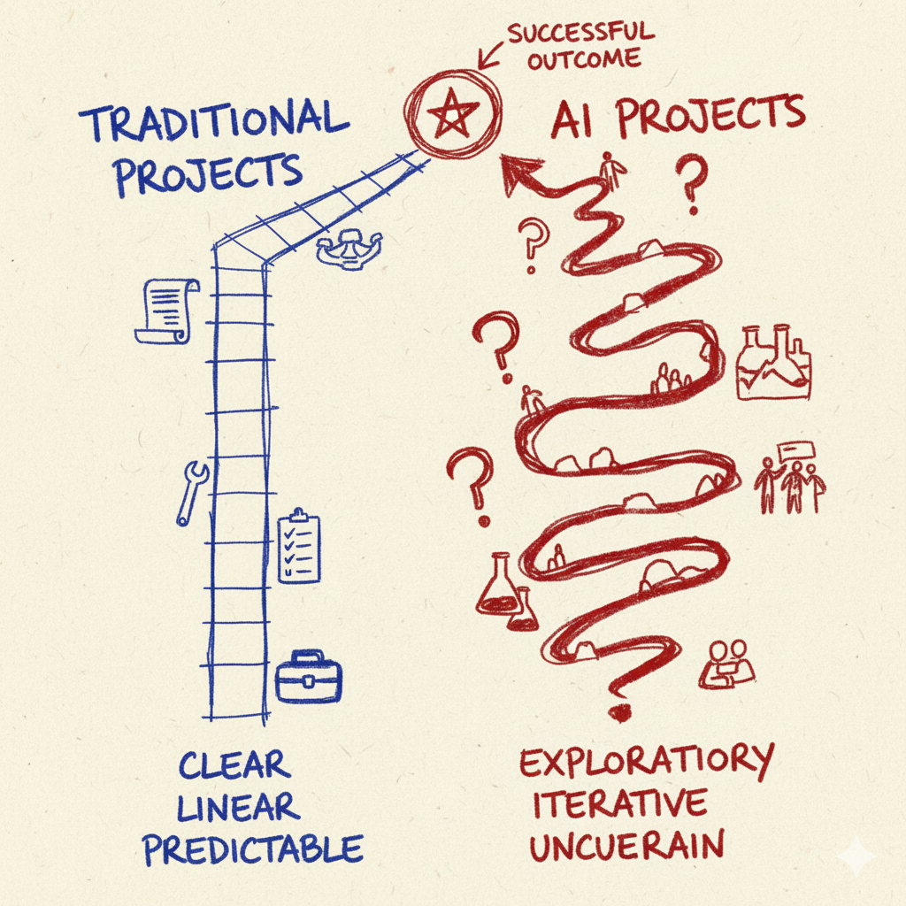

**Two Different Journeys**

Traditional: Known → Linear → Clear → Predictable → Technical risk AI: Emergent → Iterative → Evolving → Experimental → Organisational risk

* “Many of you have led successful traditional projects”
* “AI projects require DIFFERENT skills - not better or worse, different”
* “Traditional: Requirements known upfront, linear progression, success criteria clear, predictable timeline, technical risk primary, implementation focus, Gantt charts rule”
* “AI: Requirements emerge through experimentation, iterative/hypothesis-driven, success criteria evolve, we’ll know more after pilot, organisational risk dominant, learning & adaptation focus, experiments rule”
* “Today we focus on what’s unique about AI leadership”

# The AI Project Lifecycle

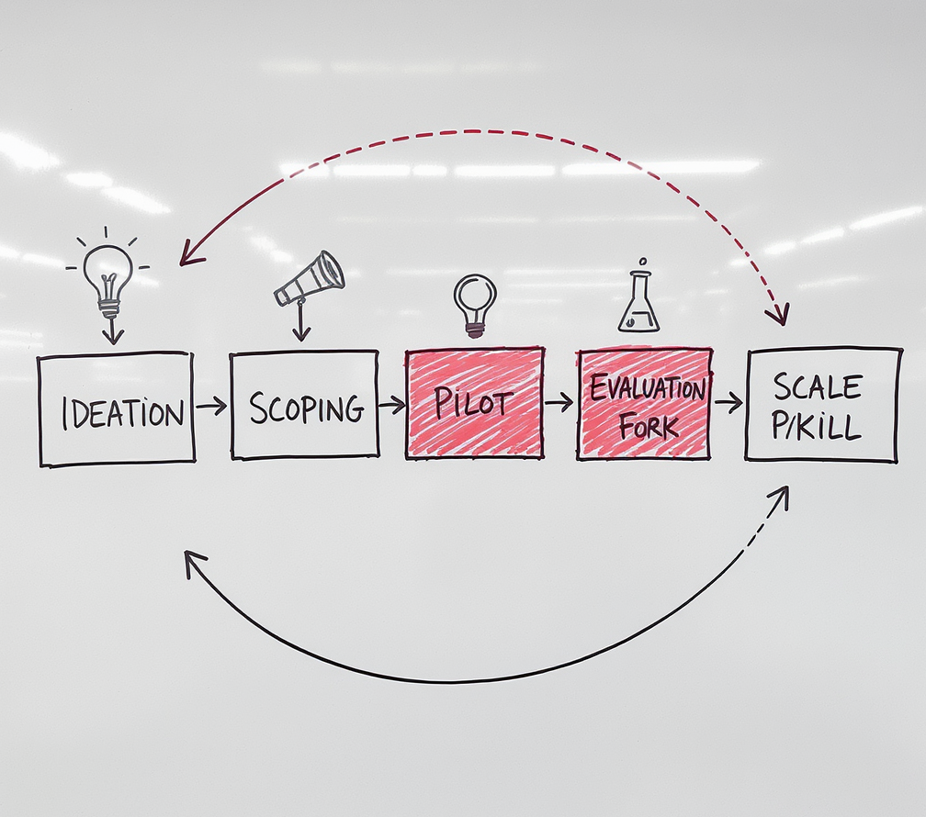

* “The journey: Ideation → Scoping → Pilot → Evaluation → Decision → Scale/Pivot/Kill (then loop back)”
* “Most organisations rush through Scoping - that’s where you design for success”
* “Most fail at Evaluation - they don’t measure the right things”
* “Most struggle with Kill decision - sunk cost fallacy is powerful”
* “Today you’ll practice the hardest parts: Scoping, Crisis Management, and Scale/Kill decisions”

# Core Framework

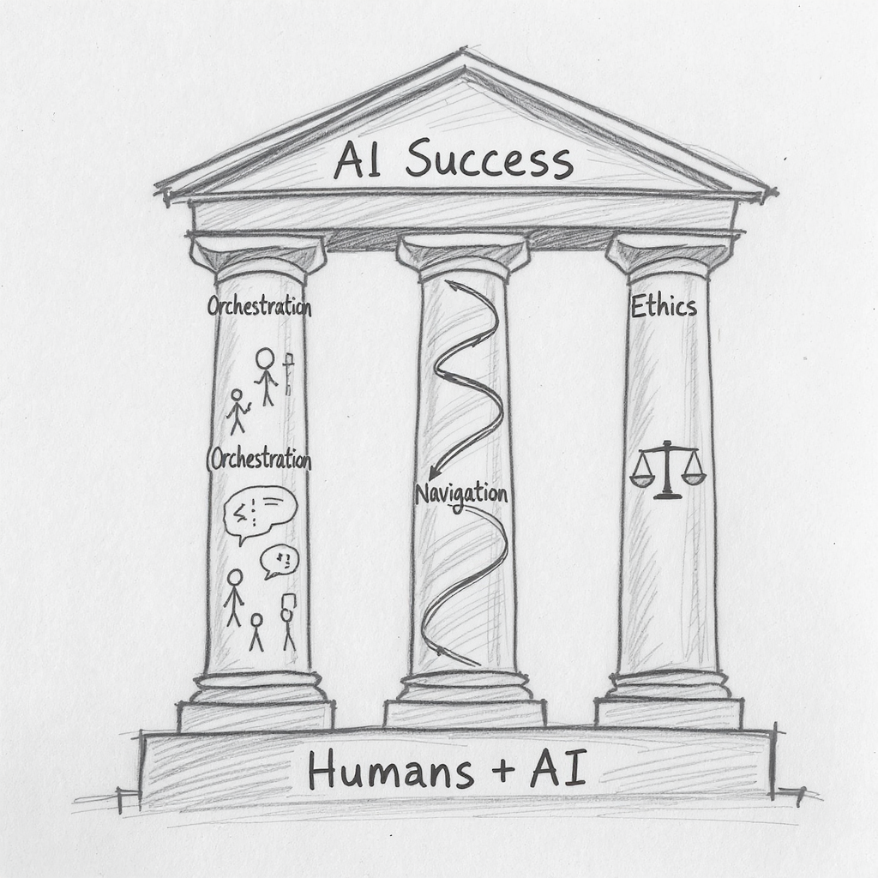

## Humans in the Loop

**AI ≠ Replace Humans** **AI = Humans + Technology Working Together**

**Three Pillars:** - Stakeholder Orchestration - Change Navigation - Ethical Leadership

* “This is the core principle: AI projects aren’t about replacing humans with technology”
* “They’re about designing new ways for humans and AI to work together”
* “This framework will guide us through every exercise today”
* “These three pillars aren’t fluffy - they’re mission-critical”
* “These pillars will help you navigate every challenge you face”
* “Stakeholder Orchestration: Align diverse interests and motivations”
* “Change Navigation: Guide organisations through AI transformation”
* “Ethical Leadership: Make values-based decisions under uncertainty”

# Meet RetailFlow

50 stores • $150M revenue • 2,000 people • Australia

**Problem:** Customer satisfaction 78% → 68%, 26-hour response times

**Solution:** AI chatbot pilot (2 weeks live)

**Your Role:** AI Project Manager

* “This is a realistic but fictional company”
* “We’ll use RetailFlow for all exercises today”
* “You are the AI Project Manager”
* “The chatbot pilot launched 2 weeks ago”
* “It’s the mix of physical retail and e-commerce that makes this complex”
* “Customer satisfaction is dropping, response times are terrible, competition is moving faster”
* “They’ve decided to try AI as the solution”
* “You’re about to face the reality of AI project leadership…”

# Exercise: Stakeholder Speed Dating

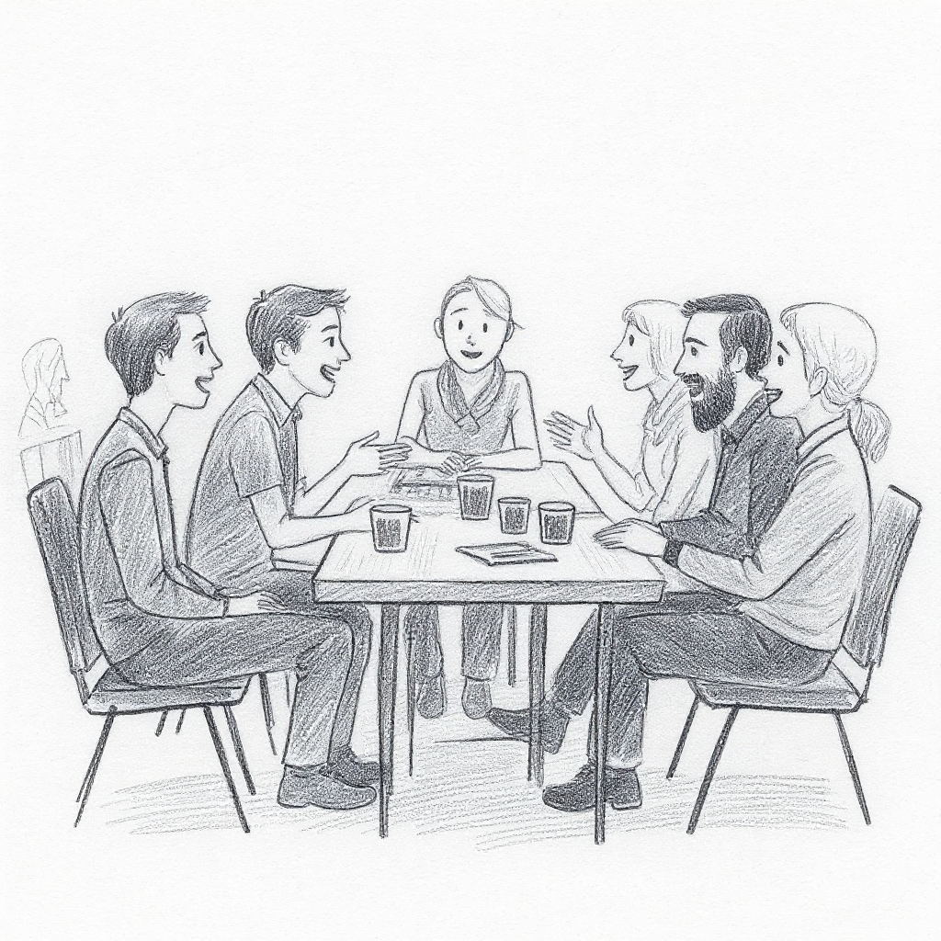

**Objective:** Experience AI project stakeholder perspectives firsthand

**What you’ll do:**

1. Each person receives a **role card** (one of 6 stakeholders)
2. Read your role card carefully
3. Have **5-minute conversations** with different stakeholders
4. Stay in character - embrace their fears and motivations
5. Take notes in your workbook

**Materials:** Role cards will be distributed now

* Distribute role cards (one per person, mixed across tables)
* Take a few minutes to read role cards
* Explain: “You’ll rotate conversations every 5 minutes when I ring the bell”
* “Stay in character - experience their perspective, not your own”
* Set timer, ring bell every 5 minutes for rotations

# Exercise: Pilot Scoping Challenge

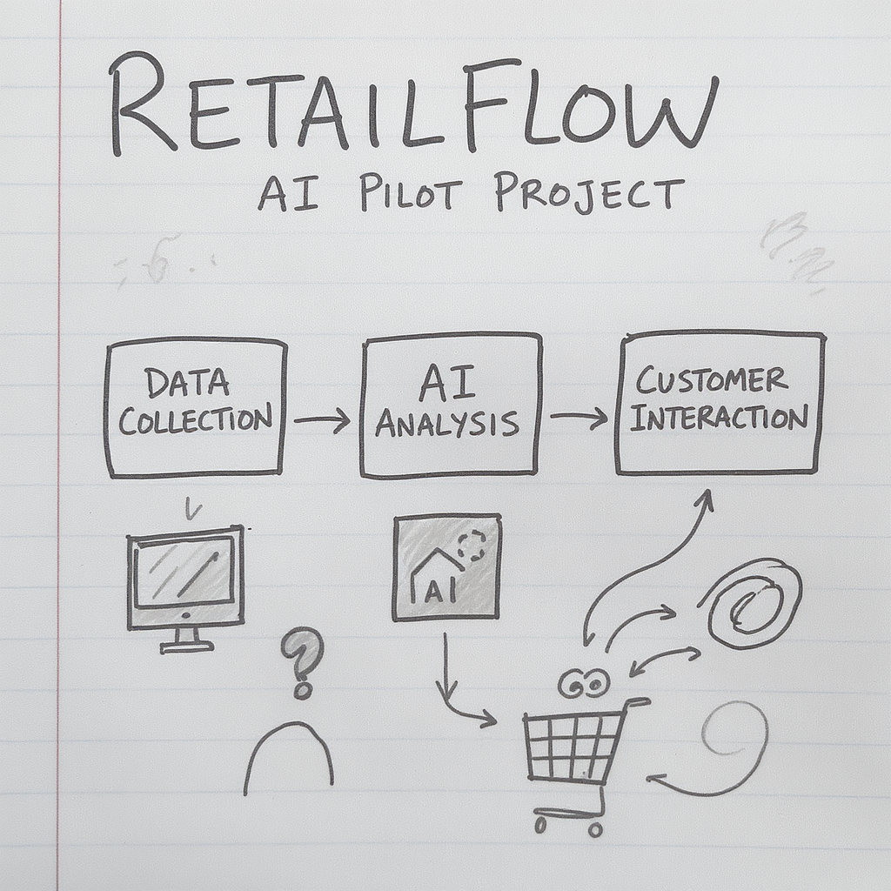

**Objective:** Design a well-scoped AI pilot for RetailFlow

**The Challenge:** RetailFlow’s customer service is broken (26-hour response times, 68% satisfaction)

**Your Task:**

1. Review the **RetailFlow case study** in your packet
2. Complete the **Pilot Scoping Worksheet** as a group
3. Define: Scope, metrics, risks, budget, timeline
4. Make it “Goldilocks perfect” - not too big, not too small

**Then… a surprise constraint will change everything**

* “All materials are in your participant packet”
* “Turn to the Pilot Scoping section”
* “You have 30 minutes to complete the worksheet”
* “One person should be scribe, but everyone contributes”
* Set 30-minute timer
* After 20 minutes: Give 10-minute warning
* After 30 minutes: Distribute ONE random constraint card per group
* “You now have 10 minutes to adapt your plan based on this constraint”

# Exercise: Crisis Management Simulation

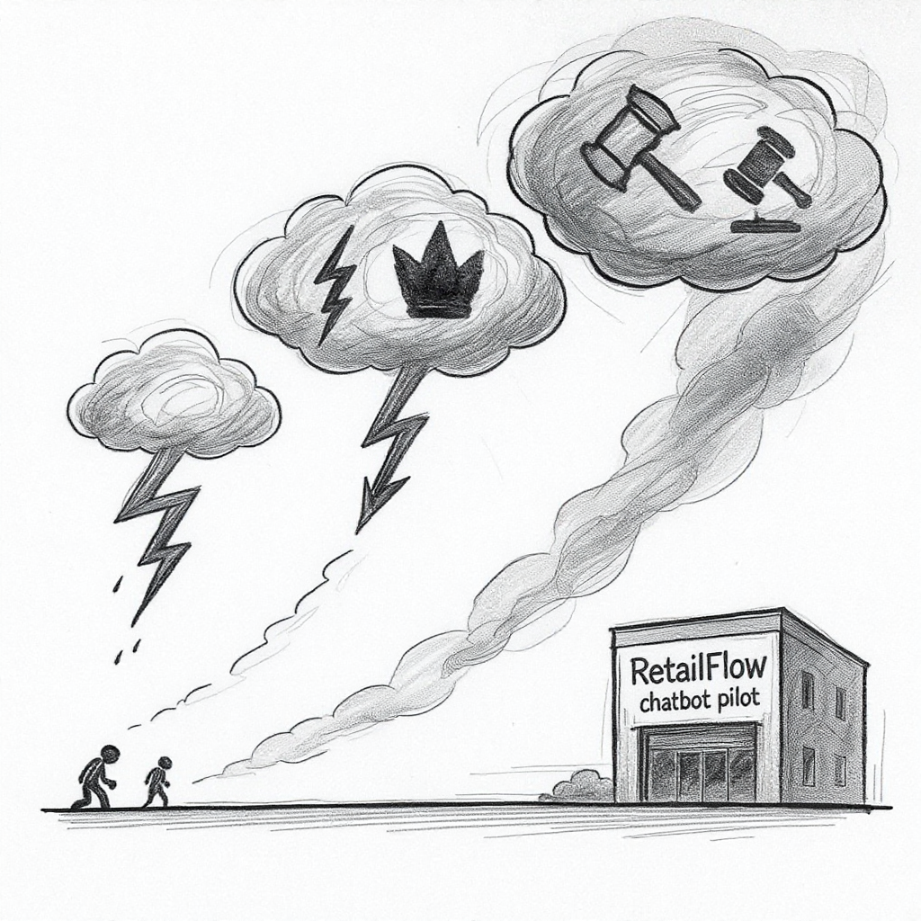

* “This is the centerpiece of the day”
* “The Scenario: You’re 2 months into the RetailFlow chatbot pilot. Week 2 of live deployment.”
* “You will face 4 crises, each one different”
* “Crisis 1: Data Quality Disaster - Technical failure, AI giving wrong answers”
* “Crisis 2: Staff Resistance - People problem, team actively sabotaging”
* “Crisis 3: Executive Pressure - Leadership challenge, sponsor demands acceleration”
* “Crisis 4: Ethical Dilemma - Values decision, AI works but discriminates”
* “Work through each crisis sequentially in your groups”
* “You’ll experience what AI project crises FEEL like”
* “Some involve role-plays with me - I’ll come to your table”
* “Diagnose, decide, communicate - under time pressure”
* “Let’s begin with Crisis 1 - Data Quality Disaster”

# Exercise: Scale or Kill Decisions

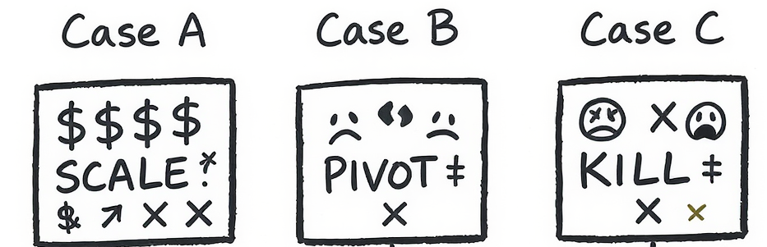

**Three Cases**

A: High ROI (but…) B: Destroyed morale C: Revenue up, satisfaction down

**Your Call: SCALE • PIVOT • KILL**

* “Now you shift from tactical to strategic thinking”
* “You’ll analyse three AI projects and make recommendations”
* “Case A: Clear Success - inventory AI with 733% ROI (but is it straightforward?)”
* “Case B: Clear Failure - scheduling AI that destroyed morale (but learn from it)”
* “Case C: Ambiguous - pricing AI, good revenue but bad customer satisfaction (no perfect answer)”
* “For each case, recommend: SCALE, PIVOT, or KILL”
* “Defend your decision with evidence and reasoning”
* “Use your Decision Framework reference sheet”
* “You have 60 minutes total”

# Personal Reflection

* “This is the most important part of the day”
* “You’ve experienced a lot - now make it personal”
* “Think about YOUR projects, YOUR challenges, YOUR context”
* “What’s the ONE thing you’ll do differently starting Monday?”
* “This is required for CRL, so complete it thoughtfully”

# Synthesis & Takeaways

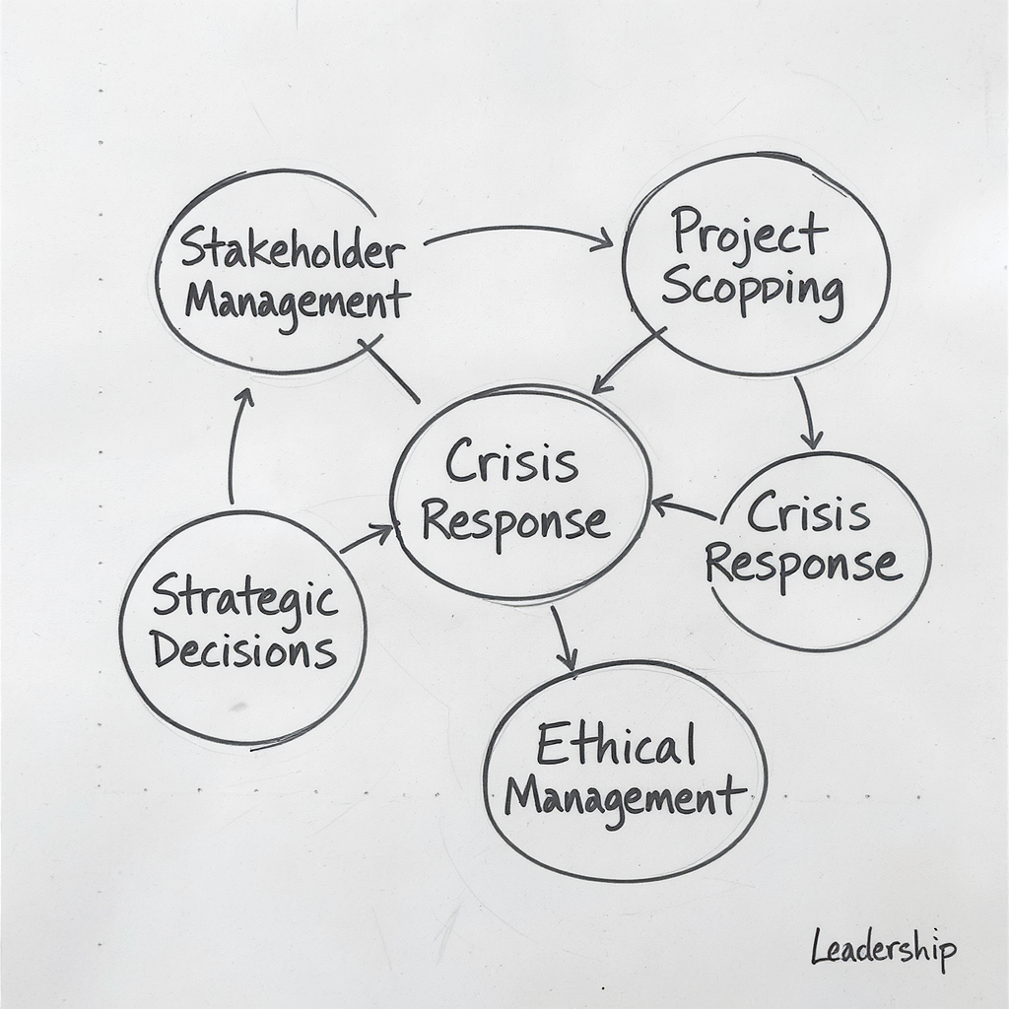

Your Toolkit: Six Frameworks

* **Stakeholder Management**
* **Project Scoping**
* **Crisis Response**
* **Strategic Decisions**
* **Change Management**
* **Ethical Leadership**
* “You’ve experienced all of these today”
* “Stakeholder Management: Power-Interest Matrix, role perspective mapping, engagement strategies”
* “Project Scoping: Goldilocks principle, success metric definition, risk mitigation planning”
* “Crisis Response: Diagnose → Decide → Communicate → Document (technical vs. people vs. leadership vs. ethical)”
* “Strategic Decisions: Scale/Pivot/Kill criteria, decision framework questions, risk assessment matrix”
* “Change Management: Expect resistance, involve early, communicate constantly, change curve navigation”
* “Ethical Leadership: Four key questions - Who benefits? What could go wrong? How do we know? When do we stop?”
* “These aren’t just frameworks - they’re practical tools”
* “Keep your reference sheet - use it on every AI project decision you face”
* “The goal isn’t perfect decisions - it’s defensible decisions with clear reasoning”

# Core Insights

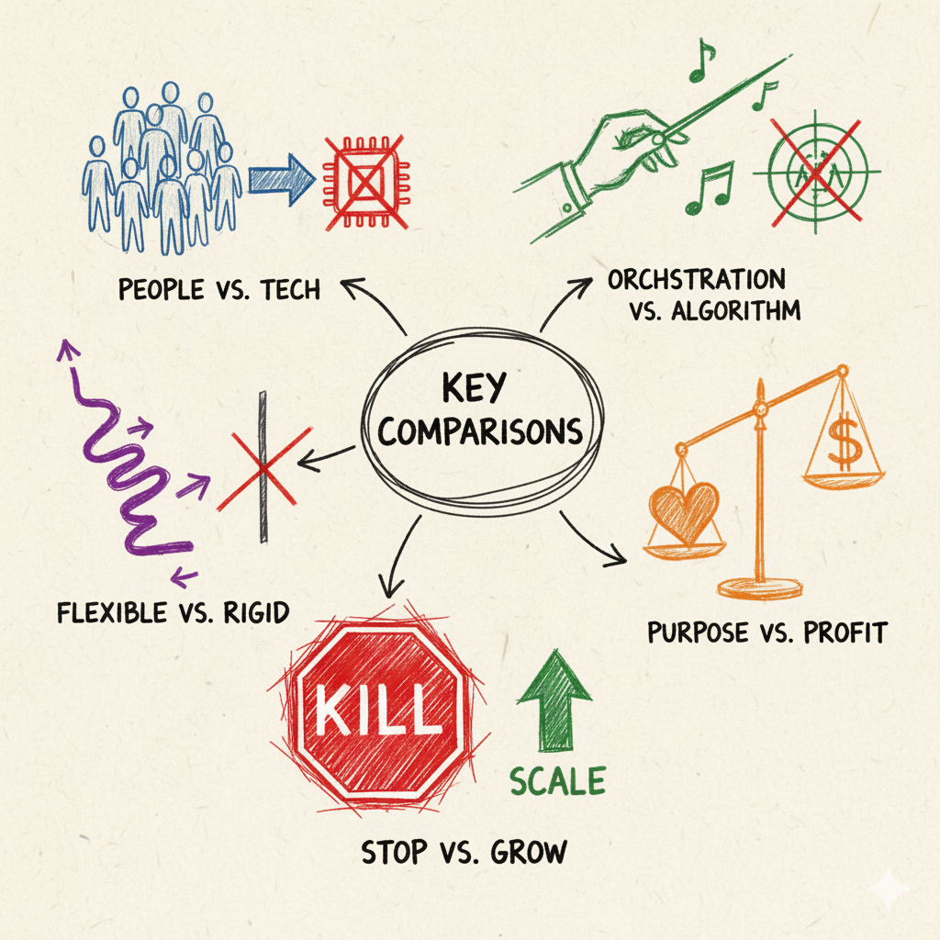

* **People > Technology**
* **Orchestration > Excellence**
* **Flexibility > Plans**
* **Ethics > Metrics**
* **Kill > Scale (if needed)**
* “AI projects fail from people issues, not technology (80% vs 20%)”
* “Stakeholder orchestration is more critical than technical excellence”
* “No plan survives first contact with reality - flexibility matters”
* “Ethical decisions aren’t optional - they’re leadership responsibilities”
* “Killing bad projects is success, not failure”
* “You experienced stakeholder resistance firsthand”
* “You made tough decisions under pressure”
* “You navigated ethical dilemmas with no perfect answers”
* “You have muscle memory now, not just theory”
* “Data-driven decisions are good, values-driven decisions are essential”
* “The cost of being wrong about scaling >> cost of being wrong about killing”
* “When in doubt, run another small experiment rather than scaling prematurely”

# Your Action Plan

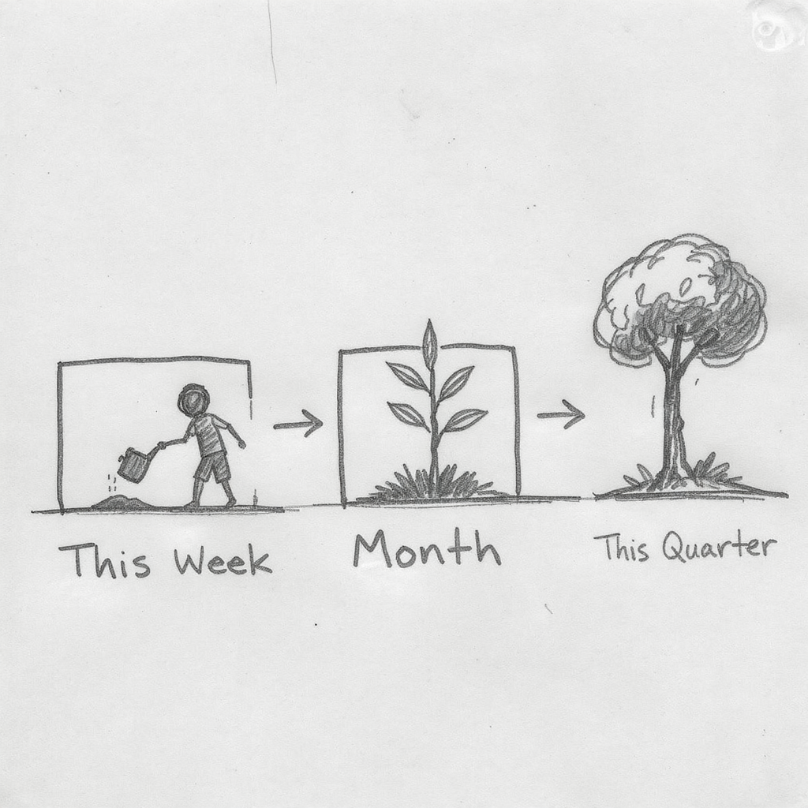

**This Week:** What will you do?

**This Month:** What will you change?

**This Quarter:** What will transform?

* “The goal isn’t to overwhelm you with a huge to-do list”
* “Pick ONE thing to do differently this week - and define why and what success looks like”
* “Then think about what you’ll change this month”
* “Then what will be different this quarter”
* “Build momentum with small wins”
* “Use the frameworks - they’re tools, not rules”

**Start small** **Measure what matters** **Involve early** **Document everything**

* “Four principles as you go back to work”
* “Start small - apply one framework at a time”
* “Measure what matters - not just what’s easy to measure”
* “Involve early - don’t wait for buy-in, co-create it”
* “Document decisions - use the frameworks to justify your choices”



* “This isn’t the end of your learning journey”
* “It’s the beginning of applying these capabilities”
* “Digital copies of all materials will be sent via email”
* “Business Innovation Masterclass is the strategic counterpart to this course”
* “The frameworks will evolve as AI technology evolves”
* “Stay curious, stay humble, stay learning”

**Apply what you learned.** **Lead with humans in the loop.** **Good luck with your AI projects!**

**Dr. Michael Borck** michael.borck@curtin.edu.au

* “Please take 3-4 minutes to complete feedback”
* “Your honest input helps us improve these masterclasses”